B. Edit Menu

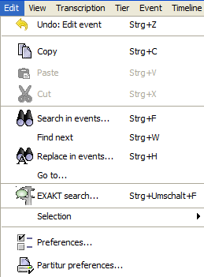 | Submenu „Selection“  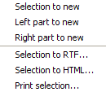

Edit > Undo
The Undo-feature was introduced in version 1.5. It reverses the last action that has been carried out. The action itself is named in the menu item (e.g. “Edit event“). Up to 20 actions are saved, which can be undone again. In the case of some actions, the musical score needs to be reformatted after calling up the menu item. This can take a few seconds in larger transcriptions.

Edit > Copy
(Shortcut: CTRL+C on Windows, ⌘+C on Mac)

Copies a selected text into the clipboard. From there, the text can be copied into any other application that has a "paste" function. Texts in different tracks are separated by “Enter”.

If the selection includes all tracks (see also second example below), a RTF-representation of the specific section of the musical score is copied into the clipboard –instead of text only. This can be copied as a musical score into RTF enabled applications (esp. WORD) by using "Paste".

Examples:

Selection in the Editor | Content of the clipboard after Copy text
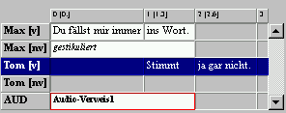 | Stimmt ja gar nicht.
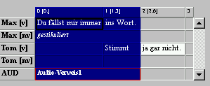 | RTF-representation of the selection of the musical score
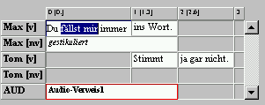 | fällst mir

Edit > Paste
(Shortcut: CTRL+V on Windows, ⌘+V on Mac)

Inserts the text from the clipboard at the current cursor position.

Edit > Cut
(Shortcut: CTRL+X on Windows, ⌘+X on Mac)

Cuts the currently selected text and puts it into the clipboard.

Edit > Search in events...
Opens a dialog in order to search events for specific characters or character strings.

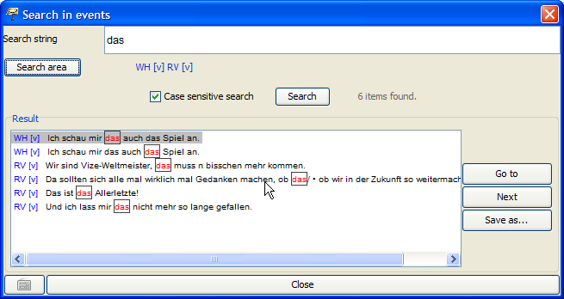

The character or string to be searched for is entered into the field "Search string“. In order to enter characters that are not available on the keyboard, you can open a virtual keyboard by using the button below on the left.

"Search area” indicates the tracks that are to be searched. When opening the search dialogue, these include, by default, all the tracks that are not hidden. In order to change the search area, click Search area: You will get the following dialogue

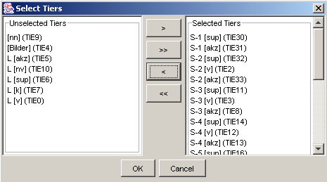

The tracks that are not to be searched are listed on the left ("Unselected tiers“). The tracks that are to be searched are listed on the right ("Selected tiers“). Click on the single arrow buttons (“>” or “<”), in order to transfer specific tracks from one list to the other. Click on the double arrow buttons (“>>” or “<<”), in order to transfer all tracks from one list to the other. Close the window by clicking OK (only then will the changes be saved).

Use "Case sensitive search“ to determine whether the use of upper or lower case initial letters should be considered as well (If this option is ticked, the use of upper and lower case initial letters will be considered).

Click Search, in order to run the search according to the defined parameters. The result of the search is given in the "Result“ list. The found occurrences are highlighted in red and in a frame.

In order to jump to a search result in the musical score, mark the result in the list and click Go to.

In order to save all the search results in a text file, click Save as... . You will then be asked to name the file. Afterwards, you will then be able to open this file with any Unicode enabled text editor. In order to close the search window, click Close.

Edit > Find next...
Jumps to the next search result in a search conducted with " Edit > Search in events...".

Edit > Replace in events...
Opens a dialog that allows searching and replacing specific characters or character strings in events.

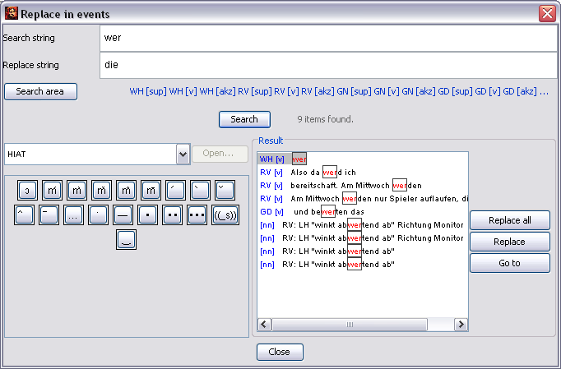

The character or string to be searched for is entered into the field "Search string“. The character or string to be replaced is entered into the field "Replace string“. The determination of the "Search area“ is done as described above ("Edit > Search in events…“).

Searching and replacing always considers the use of capital and small initial letters.

In order to jump to a search result in the musical score, mark the result in the list and click Go to.

In order to replace specific search results, first click Search. The results are listed in the "Result“ list. In order to replace a specific result, mark it and click Replace.

In order to replace all of the results click Replace all. Please note: This procedure can not be undone! It is therefore advisable to save the transcription before using the replace function, in order to be able to reverse the process by using “File > Restore” (see above).

Edit > Go to...
By using the "Go to..." dialogue, you can navigate to specific positions in the musical score. You can either specify an absolute time value ("Go to time") or a position on the timeline "Go to timeline item".

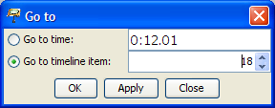

By using the button "Apply", you can jump to the specified position. Clicking "OK" also closes the dialogue.

Edit > EXAKT search...
Opens a dialog for an EXAKT-search .

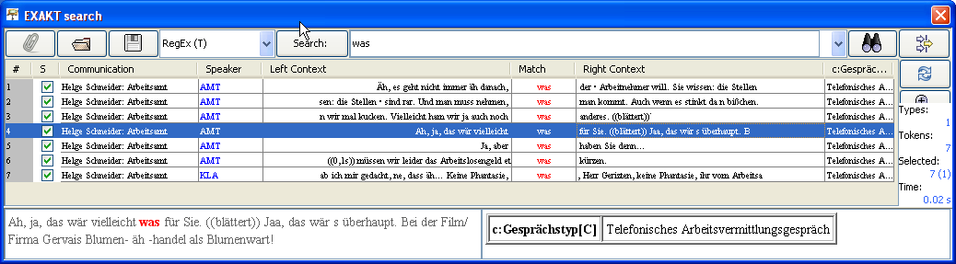

To see how the EXAKT search works, see Einführung in das Suchwerkzeug EXAKT.

Edit > Selection
This submenu includes features that concern a previously selected part ("Selection“) of the transcription. In essence, this selection is made up of all displayed tracks. It can be reduced in two ways (which can also be combined): Entire tracks can be removed from the selection by dismissing them with the function Tier > Hide tier. If only specific time points are to be selected, mark the section on the time line by using the mouse (click and drag).

Example:

Initial transcription:
The selection includes all time points of the seven tiers.

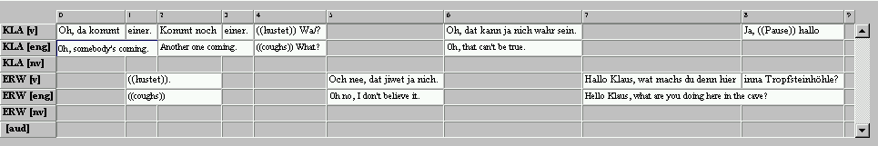

After hiding the non-verbal tiers and translation tiers:
The selection includes all time points of the remaining three tiers.

After selecting a section on the time line:
The selection only includes the time points 4 to 6 of the three remaining tiers.

The second step is to determine what will happen to the previously made selection. The Partitur-Editor offers five different options for this:

Edit > Selection > Selection to new
Turns the current selection into a new transcription. For example c) named above:

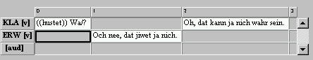

Edit > Selection > Left part to new
Divides the transcription at the current cursor position or selection and turns the part left to the position into a new transcription.

Edit > Selection > Right part to new
Divides the transcription at the current cursor position or selection and turns the part right to the position into a new transcription.

Edit > Selection > Selection to RTF
Turns the current selection into an RTF musical score output (see "File > Output…“).

Edit > Selection > Selection to HTML
Turns the current selection into an HTML musical score output (see "File > Output…“).

Edit > Selection > Print selection…
Prints the current selection (see also "File > Print…“).

Edit > Preferences…
Opens a window to determine user-defined settings. The window is divided into eight subitems:

1. Fonts: The tab "Fonts“ allows the assignment of default-fonts and methods for underlining.

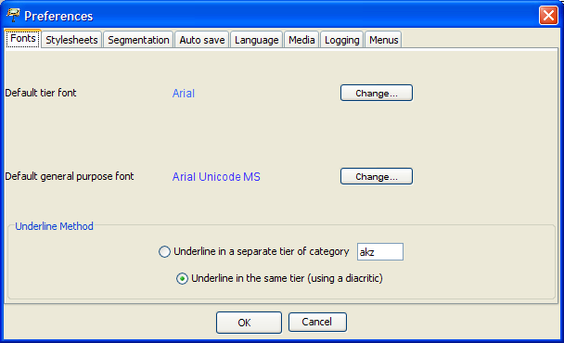

The "Default tier font“ is the standard font, which is automatically assigned to new tiers or into which an opened transcription is formatted.
The "Default general purpose font“ is the font which is used by default for the characters on the virtual keyboard, as well as for the text box above the musical score. For this you should pick a font that covers as many Unicode areas as possible. Currently, the best font for this purpose is "Arial Unicode MS“. A freeware alternative, even though it is still incomplete in some Unicode areas, is "Gentium“, which was developed by the "Summer Institute of Linguistics“ (see also: http://www.sil.org/~gaultney/gentium/).

Click Change… in order to open a window in which you can choose a different font.

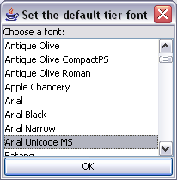

In order to save your changes, click OK. (The settings will be saved when closing the Editor and are loaded again at the next start.)

There are two options for selecting the method of underlining:
- The option "Underline in a separate tier of category […]" underlines a selected passage in an annotation tier below the respective tier. This corresponds to the method recommended in the HIAT handbook for the marking of special intonations.
- The option "Underline in the same tier (using a diacritic)" results in the underlining of a selected text in the same tier by diacritics after every sign.
For particulars about underlining, see also "Format > Underline".

- Stylesheets:
Different stylesheets are defined in the tab "Stylesheets“ (also see Appendix D):

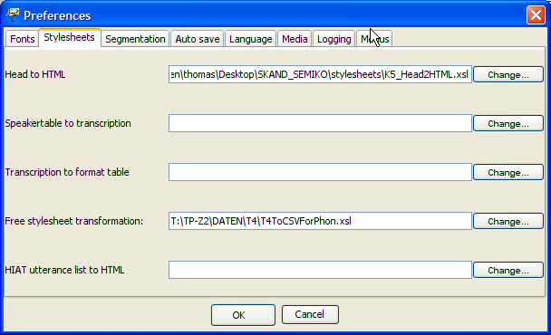

In particular, these are:
  - Head to HTML: The stylesheet that is used in the HTML output to display meta information and the speaker table. The entry can be left empty; an internal default stylesheet will be used.
  - Speakertable to transcription: The stylesheet that is found under the menu item „File > New from speakertable…“ generates a new transcription from a speaker table. The entry can be left empty; an internal default stylesheet will be used.
  - Transcription to format table: The stylesheet that is found under the menu item „Format > Apply stylesheet“ is used to format the transcription. The entry can be left empty; an internal default stylesheet will be used.
  - Free stylesheet visualization: This stylesheet is found under the menu item "File > Visualization > Free stylesheet visualization“.
  - HIAT utterance list to HTML: This stylesheet is found under the menu item “Segmentation > HIAT Segmentation > Utterance List (HTML)”.

In order to change the entries, click on the respective Change... button. A file window will allow you to select the particular stylesheet.

3. Segmentation: In the tab "Segmentation“ you can define settings for segmentation. These settings affect several menu items of the Transcription menu. In “Preferred Segmentation” you can set your preferred segmentation algorithm. In “Finite State Machines” you can define custom Finite State Machines for the segmentation algorithms.

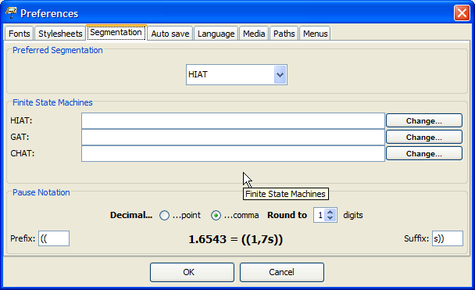

In particular, these are:
HIAT: The finite state machine that describes the segmentation algorithm for HIAT files. These are used for various functions under "Segmentation > HIAT Segmentation“ (see section H of the function references and Appendix B).
DIDA: The finite state machine that describes the segmentation algorithm for DIDA files. These are used for various functions under "Segmentation > DIDA Segmentation“ (see section H of the function references and Appendix B).
GAT: The finite state machine that describes the segmentation algorithm for GAT files. These are used for various functions under "Segmentation > GAT Segmentation“ (see section H of the function references and Appendix B).
CHAT: The finite state machine that describes the segmentation algorithm for CHAT files. These are used for various functions under "Segmentation > CHAT Segmentation“ (see section H of the function references and Appendix B).

Furthermore, you can use this dialog to choose the form of pauses that are inserted via “Event > Insert p ause...” Prefix states which characters precede the pause description. Suffix defines which characters follow. Via Decimal you can define whether a decimal point or a comma is used. Round to defines the number of digits behind the comma, to which the pause measurement is rounded. The settings automatically adapt to the transcription system that has been selected under Preferred Segmentation.

4. Auto Save: In the tab "Auto save“ you can choose if you would always like to create an automatic backup copy of the transcription you are working on.
The automatically generated backup copy will save your data in case of a system crash, as you are able to restore your transcription from the backup copy. If this option is activated, a backup copy with a clear name is created for the session, every time the Editor is started.

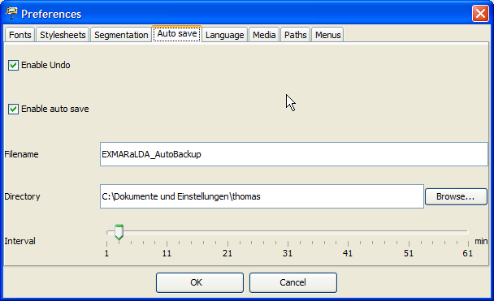

You can use the following settings:
Enable undo: The undo function ("Undo“) in the "Edit“ menu is activated
Enable auto save: The generating of an automatic backup copy is activated.
Auto save file name: Accept the suggested file name or change it.
Auto save path: Accept the suggested save location for the backup file or select Browse… in order to change the location.
Auto save interval: The data is automatically copied into the backup copy in intervals. The shorter the saving intervals, the better protected your data is. However, the capacity of your internal memory is also used more frequently. The preset "ten-minute-interval“ has proven itself to be a reasonable choice here. However, if required you may increase or decrease this time interval.

5. Languages: In the tab "Language" you can define the language in which you would like to work with the EXMARaLDA Partitur-Editor.

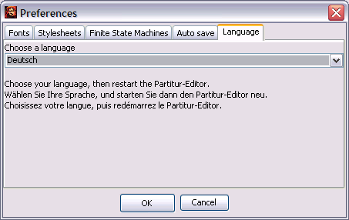

Select the language that you would like to use from the drop-down list. Save your settings by clicking OK. Then you will have to close and restart the Partitur-Editor. After this step, the language change is activated.

6. Media: In the tab "Media“ you can define the player that you would like to use for playing audio and video files.

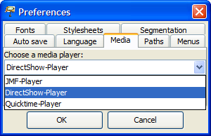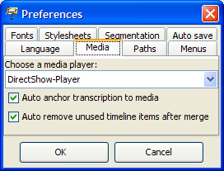

Usually, the default player (DirectShow on Windows, ELAN-Quicktime on MAC, JMF on Linux) is the best choice. In order to activate changed settings, the Editor has to be restarted. For further information, please consult the document Audio and Video support in EXMARaLDA.

Furthermore, you can define different parameters for the behaviour of the time line in the musical score:
- Auto anchor transcription to media: if this option is selected, the transcription is automatically linked to an assigned recording. The first time point on the time line has the value 0.0, the last time point has the value of the end of the recording.
- Auto remove unused timeline items after merge: If this option is chosen, an automatic check searches for unused time points on the time line after events have been merged. If there are any, they will be removed.

7. Paths: Here you can firstly define, into which directory the Partitur-Editor writes the Log file (the file with error messages etc.: "Log file directory"). Secondly, you can define in which directory ("Praat directory") the programs “praat.exe” and “sendpraat.exe” are located, which is necessary for using the Praat panel.

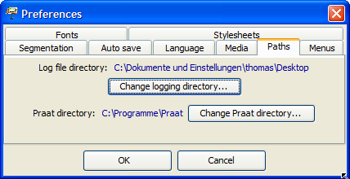

8. Menus: Here you can show and hide project specific menus.

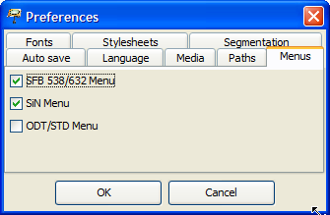

Edit > Partitur preferences…
Opens a window in which parameters can be defined for the output as a musical score on a printer, as an RTF file, as an HTML file or as an XML-file (see also "File > Output...“). The window is divided into five subitems:

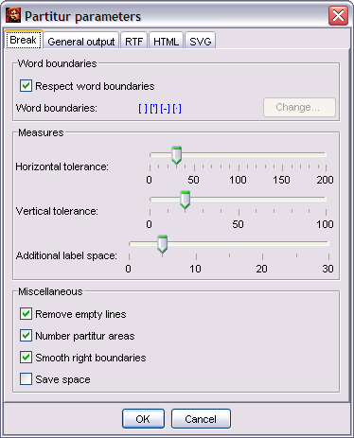

The tab "Break“ allows you to set the parameters for line and page break:
- Respect word boundaries: defines whether word boundaries (spaces, apostrophes, hyphens) should be taken into consideration at a break, meaning whether breaks in the middle of a word should be prevented.
- Horizontal tolerance: defines a range of tolerance for the width of the break. The higher this value, the fewer small units will be fragmented at a break. However, there will be a greater musical score area.
- Vertical tolerance: defines a range of tolerance for the page brake. If you encounter problems with the page break (which can be the case, depending on the printer used), adjust this value.
- Additional label space: determines an additional space between the tier labels and the first entry.
- Remove Empty Lines: determines, whether empty lines that resulted from a page or line break should be removed.
- Number partitur areas: determines if the “Partitur Areas” are numbered consecutively.
- Smooth right boundaries: defines whether the right “Partitur Area” boundaries should be smoothed out to one line (This only works for printer and RTF-output, not for HTML-output).
- Save space: determines, whether empty lines should be "reduced" at output after a break. The numbering of the musical score would be slightly indented in this case:

Option "Save Space“ deactivated: | Option "Save Space“ activated:
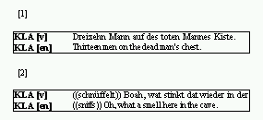 | 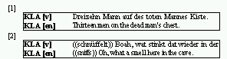

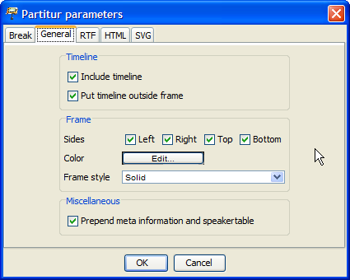

In the tab "General“ further parameters can be set, which apply to all forms of output (meaning printer, RTF, HTML and XML):
Include timeline in output: determines whether the entries on the time line (numbering and/or absolute time values) are to be included in the output.
Put timeline outside frame: determines whether the entries on the time line are going to be inside or outside of the musical score area.
Frames: defines how the Partitur Areas are framed. "Left", "Right", "Top", "Bottom" determine whether the frame lines are drawn on the left, the right, at the top or the bottom. "Color" specifies the colour of the frame (click the button in order to open a window to choose a colour). "Frame style" specifies whether the framing lines are "solid", "dashed“ or dotted.
Prepend meta information and speakertable: defines whether the meta information and the speakertable are to be included in the output or not (only valid for RTF and HTML output). Please note that it is relevant for HTML output which stylesheet is specified and if a stylesheet is specified. These specifications are made under "Edit > Preferences...“ in "Head to HTML“.

Examples:

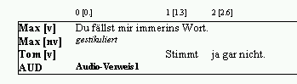 | The entries on the timeline were included in the output (outside of the frame). The Partitur Area is framed with a solid line.
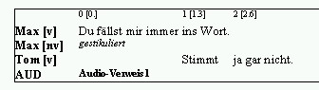 | The entries on the time line were included into the output (inside of the frame). The Partitur Area is framed with a solid line.
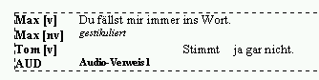 | The entries on the time line were not included into the output. The Partitur Area is framed with a dotted line.

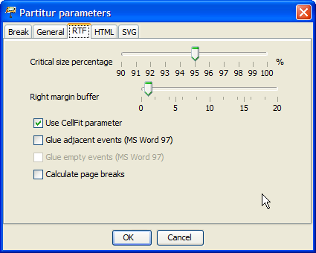

In the tab "RTF“, you can specify parameters which are specially used for RTF output. RTF output can be problematic, as the calculation processes of Java do not match those of MS Word entirely. Thus, displacement and missing characters may occur. Some of the here mentioned parameters serve the purpose of compensating those inaccuracies (see the sections " Ausgeben einer Transkription“ in the tutorial).
- Critical size percentage: defines from what extend onward the size of an entry in a musical score line is considered critical. This means it states from which point onward the mechanisms for the compensation of inaccuracies are to be applied. The preset 95% has proven to be a reasonable value here. You can, of course, increase or decrease this figure, if required.
- Right margin buffer: defines a buffer area at the right margin of the Partitur Area. This can be done in order to compensate inaccuracies in the calculation. If the options “Glue adjacent IT elements“ and "Glue empty IT elements“ (see below) are deactivated, this value can be 0. Otherwise, it should be set to a value between 5 and 20.
- Calculate page breaks: specifies whether page breaks are to be calculated for the RTF document.
- Glue adjacent events: specifies whether adjacent events in the Partiturzeile should be combined once the first one has reached the critical size. For MS Word 97 this option has to be selected. For MS Word 2000 it has the small disadvantage that Synchronverhältnisse may possibly shift a little bit. However, it also has the advantage that words that have been "torn apart" due to synchronisation will be put back together. Do not use this option in MS Word 2000 if you are working with framing single elements.
- Glue empty events: specifies whether empty events in the Partiturzeile should be combined with the preceding element. Do not use this option if you are working with framing or underlining single elements in colour.
- Use CellFit parameter: specifies whether the "CellFit“ parameter is used. The activation of this option helps to prevent mistakes, which can occur when reading output RTF files in MS Word 2002 (= Word XP).

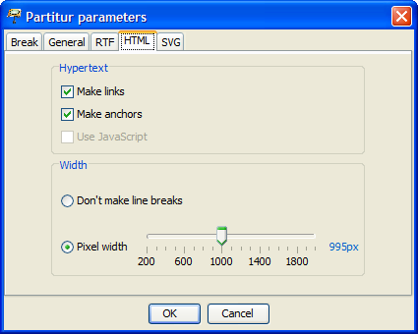

In the tab "HTML“, you can specify parameters which are specially used for HTML output.
- Make links: specifies whether links that have been made in the transcription should be implemented as hyperlinks in HTML.
- Make anchors: defines whether anchors should be assigned to the Partitur Area – meaning links for outside reference. In order to work with the wordlist output (see below), this option has to be checked.
- Use JavaScript: specifies whether JavaScript functions are used (to link the tier labels with the speaker table).
- Don’t make line breaks: Checking this option creates an endless musical score, hence the musical score is not divided by line breaks.
- Pixel width: When this option is checked, the musical score is divided at the set width (in pixels). A value between 400 and 600 is suitable for most common monitors. In order to work with the word list output (see below), the musical score needs to be divided like this.

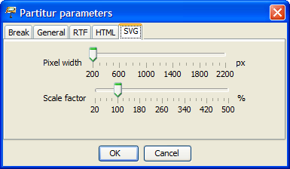

In the tab "SVG“ you can specify parameters which are specially used for SVG output.:
Pixel width: defines the Umbruchbreite (???)of the musical score This means it specifies the the width of specific Partitur Areas) in pixels.
Scale factor: specifies the scale factor (in percent). This value increases or decreases the musical score in the output.

